**NITTE MEENAKSHI INSTITUTE OF TECHNOLOGY**

(AN AUTONOMOUS INSTITUTION, AFFILIATED TO VISVESVARAYA TECHNOLOGICAL UNIVERSITY, BELGAUM, APPROVED BY AICTE & GOVT.OF KARNATAKA



**COURSE PROJECT REPORT**

on

**CLINICAL APPOINTMENT BOOKING SYSTEM**

*Submitted in partial fulfilment of the requirement for the award of Degree of*

*Bachelor of Engineering*

*in*

*Computer Science and Engineering*

Submitted by:

|  |  |
| --- | --- |
| KUMUDA K | 1NT18CS082 |
| RITIKA SUBUDHI | 1NT18CS133 |
| SHEETAL S HARSHINI | INT18CS149 |
| SHREYA A HEGDE | 1NT18CS153 |



**Department of Computer Science and Engineering**

2019-20

|  |  |  |
| --- | --- | --- |
|  | **Nitte Meenakshi Institute of Technology**  (AN AUTONOMOUS INSTITUTION AFFILIATED TO VISVESVARAYA TECHNOLOGICAL UNIVERSITY, BELGAUM)  PB No. 6429, Yelahanka, Bangalore 560-064, Karnataka  Telephone: 080- 22167800, 22167860  Fax: 080 – 22167805 |  |

**Department of Computer Science and Engineering**

**CERTIFICATE**

This is to certify that the Course Project titled “ABS HOSPITAL APPOINTMENT BOOKING SYSTEM” is an authentic work carried out by **Kumuda K (1NT18CS082), Ritika Subudhi (1NT18CS133), Sheetal S Harshini (1NT18CS149)** and **Shreya A Hegde (1NT18CS153)** bonafide students of **Nitte Meenakshi Institute of Technology**, Bangalore in partial fulfilment for the award of the degree of ***Bachelor of Engineering*** in COMPUTER SCIENCE AND ENGINEERING of Visvesvaraya Technological University, Belagavi during the academic year ***2019-2020.***

Dr Vijaya Shetty Dr. Thippeswamy M. N

|  |  |  |
| --- | --- | --- |
| **Name Signature of the Guide** |  | **Name and Signature of the HOD** |

**DECLARATION**

We hereby declare that

(i) This Presentation does not contain text, graphics or tables copied and pasted from the Internet, unless specifically acknowledged, and the source being detailed in the report and in the References sections.

(ii) All corrections and suggestions indicated during the internal presentation have been incorporated in the report.

(iii) Content of the report has been checked for the plagiarism requirement

Name USN Signature

|  |  |  |
| --- | --- | --- |
| Kumuda K | 1NT18CS082 |  |
| Ritika Subudhi | 1NT18CS133 |  |
| Sheetal S Harshini | 1NT18CS149 |  |
| Shreya A Hegde | 1NT18CS153 |  |

**Date: 30/03/2020**

**ACKNOWLEDGEMENT**

The satisfaction and euphoria that accompany the successful completion of any task would be incomplete without the mention of the people who made it possible, whose constant guidance and encouragement crowned our effort with success. We express our sincere gratitude to our Principal **Dr. H. C. Nagaraj**, Nitte Meenakshi Institute of Technology for providing the facilities.

We wish to thank our H.O.D**, Dr. Thippeswamy MN** for the excellent environment created to further educational growth in our college. We would also thank him for the invaluable guidance provided which has helped in the creation of a better technical report.

We would like to convey our heartfelt gratitude to our Guide **Dr. Vijaya Shetty** for guiding and supporting us throughout and helping us make this project a successful one.

We also thank all our friends, teaching and non-teaching staff at NMIT, Bangalore, for all the direct and indirect help provided in the completion of the presentation.

Name USN Signature

|  |  |  |
| --- | --- | --- |
| Kumuda K  Ritika Subudhi  Sheetal S Harshini  Shreya A Hegde | 1NT18CS082  1NT18CS133  1NT18CS149  1NT18CS153 |  |

Date: 30/03/2020

**ABSTRACT**

Clinical Appointment Management System enables both the user and the clinic to book and manage appointments respectively in a hassle-free manner. It provides the benefits of streamlining operations, enhanced administration and control and improved response. It provides easy access to doctor’s timings, availability and holidays.

The idea behind this project is to provide the clinic with a database system with the help of which it can get rid of manual procedures. A system is needed that can maintain the patient’s name, age, doctor they wish to book an appointment with, appointment time & date, the patient’s medical report, prescription details and the list of laboratory tests.

**TABLE OF CONTENTS**

|  |  |  |
| --- | --- | --- |
| Index | Chapters | Page No |
| 1. | Introduction | 7 |
| 1.1. | Literature Survey | 8 |
| 1.2 | Correlating theoretical concepts to practical implementation | 9 |
| 1.3 | Flow Diagram/Design of System and Implementation | 11 |
| 2. | Result and snapshots | 13 |
| 3. | Conclusions | 20 |
| 4. | Bibliography | 21 |

Chapter 1

**INTRODUCTION**

Health care is one of the fastest growing industry all over the world. Before the last few years, medical appointments were usually taken on the phone calls or by visiting the hospitals in person. This process needed the involvement of individuals so, the ability to take appointment was restricted to the availability of schedulers, phone lines or the physical presence of a person.

With the growth of time, everybody demanded timeless and efficient medical care delivery because manual appointments (that requires the physical presence of both individuals) and long waiting lines have formed an irritating situation for the healthcare institutions. So, it created a need for such an integrated health care system that could deliver seamless care to both outpatients as well as inpatients. The emergence of online appointment system offered timeless and efficient access to health care services. Therefore, for hospitals and other medical societies, online appointment booking has a great importance and a subject of interest.

Booking appointment online has become a new trend because it reduces the patient and doctors’ idle time. A well-designed clinical appointment system is supposed to improve patients’ satisfaction by reducing cost and time of clinics and hospitals especially in the busy lives we are leading today. It also acts as a better system to keep track of a patients’ medical history and list of reports. The soft copy of the report is accessible whenever the patient needs it. This low-cost system delivers health care services at its best.

* 1. **Main Purpose**

The main purpose of this project is to create an online application for patients to access their medical history and also to book appointments conveniently.

* 1. **Objective of the project**
* Digitalize the appoint booking system
* Reduce manual effort and paper work
* Avoid confusions related to doctor’s timings and availability
  1. **Project Scope**

The users can participate only if they have created an account through the registration form and have provided their medical history. Once they get registered themselves, they would not need to update their record as it would be done automatically after each doctor’s visit.

Chapter 2

**LITERATURE SURVEY**

**Present System:**

In the present system you have to call the clinic to book an appointment because many small hospitals do not have an online appointment booking system. The complete process of sharing the patient details has to be done manually each time an appointment is booked. The patient needs to enquire about the doctor’s availability schedule over a phone and if the receptionist gets it wrong the treatment might be delayed.

The patient needs to carry the hardcopy of the previous reports every time they meet the doctor. This is a bothersome task. There is a high possibility of losing those documents as well.

**Proposed System:**

This clinical appointment management developed, aims to automate this process. Using this system, the user can book an appointment conveniently and also access their reports anytime. The patient’s medical history has to updated only once by the user.

 Customer can login into the system by giving valid username and password. After login one can check the availability of the doctors and book an appointment or view the list of prescriptions and medical reports.

**Technology used:**

Software:

* Java SDK
* Java FX plugin
* SQL connector
* Eclipse IDE

Hardware: No specific requirements, works on any laptop or personal computer.

Chapter 3

**CORRELATING THEORETICAL CONCEPTS TO PRACTICAL IMPLEMENTATION**

* **Encapsulation**

The whole idea behind encapsulation is to hide the implementation details from users. If a data member is private it means it can only be accessed within the same class. No outside class can access private data member (variable) of other class. In our project we have used encapsulation concept in class ABS_Hospital.

* **Inheritance**

Inheritance can be defined as the process where one class acquires the properties (methods and fields) of another. With the use of inheritance, the information is made manageable in a hierarchical order. The class which inherits the properties of other is known as subclass (derived class, child class) and the class whose properties are inherited is known as superclass (base class, parent class). In our program, ABS_Hospital extends Application class.

* **Polymorphism**

means one name many forms. In Java, polymorphism can be achieved by [method overloading](https://www.java2blog.com/2014/06/method-overloading-in-java.html) and [method overriding](https://www.java2blog.com/2014/06/method-overriding-in-java.html). In the project we have used predefined interfaces like Observable list.

* **JDBC (Java Database Connectivity)**

We use the JDBC API to handle the database using our Java program which can perform the following activities:

1. Connect to the database
2. Execute queries and update statements to the database
3. Retrieve the result received from the database.

Chapter 4

**4.FLOW DIAGRAM**

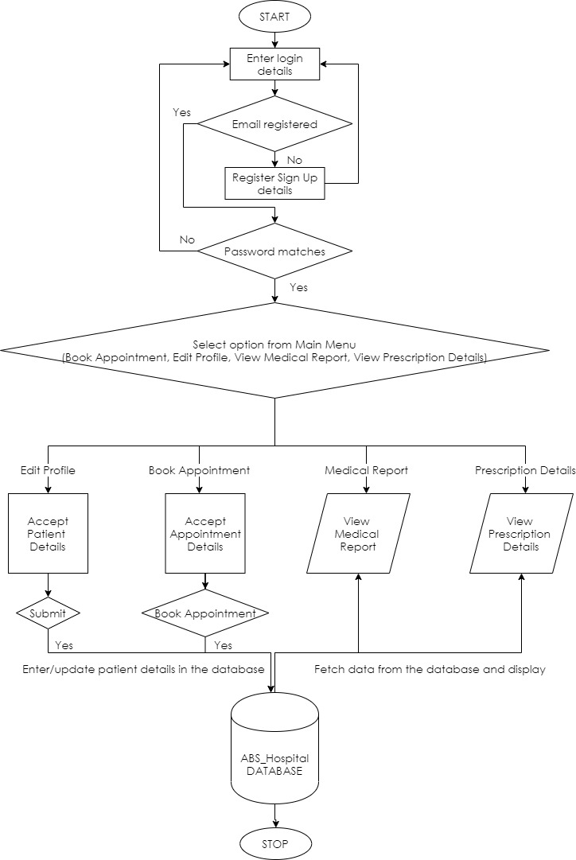

Chapter 5

**RESULTS/SNAPSHOTS**

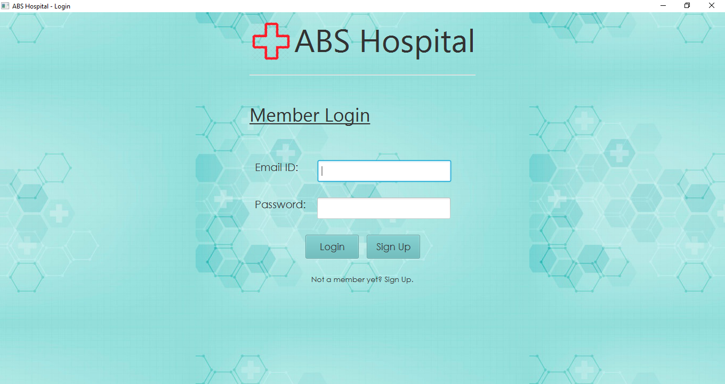

Fig. Login page .

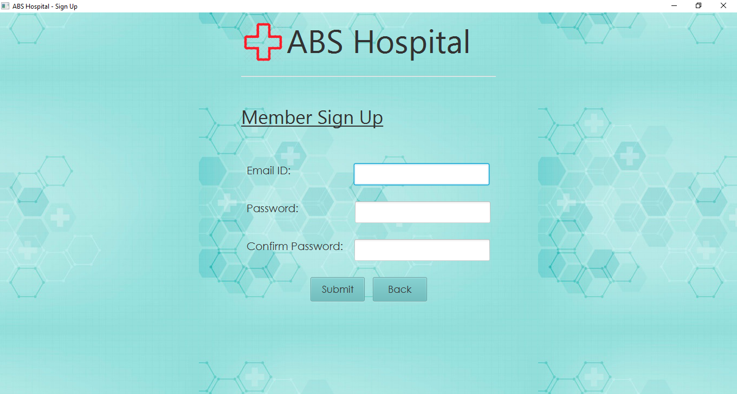

Fig: Sign-up page.

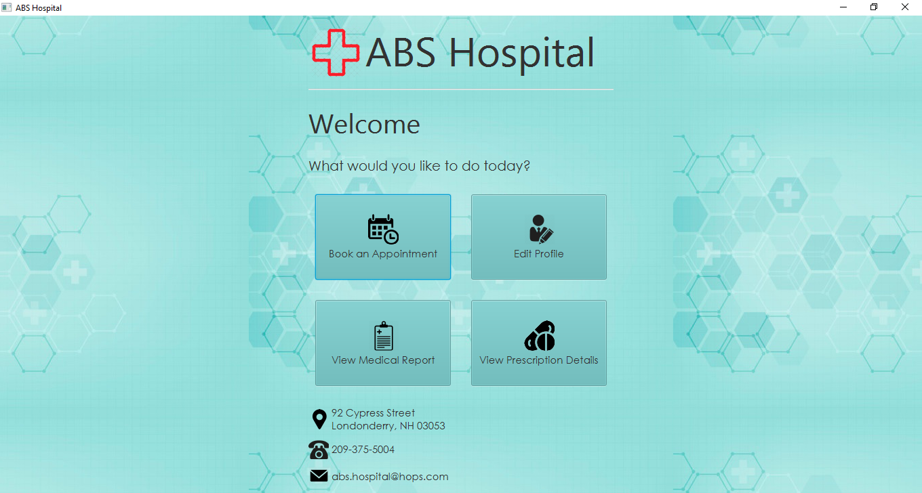

Fig: Home page.

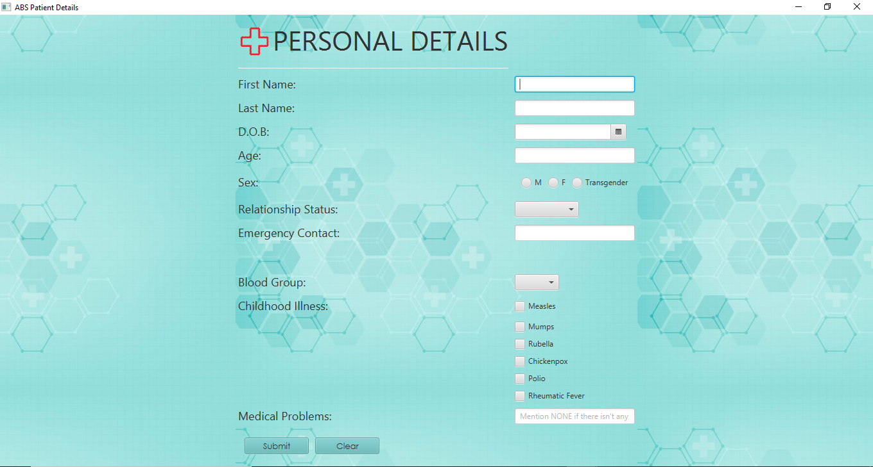

Fig: Personal Details.

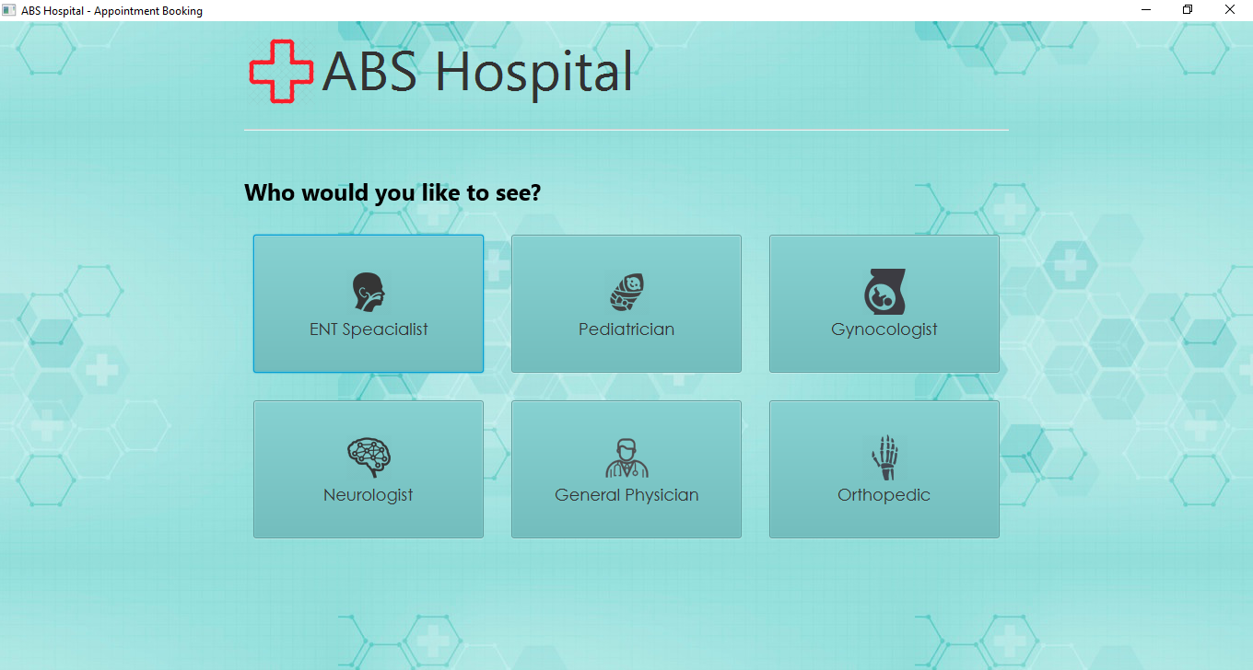

Fig: Departments of ABS Hospital for appointment.

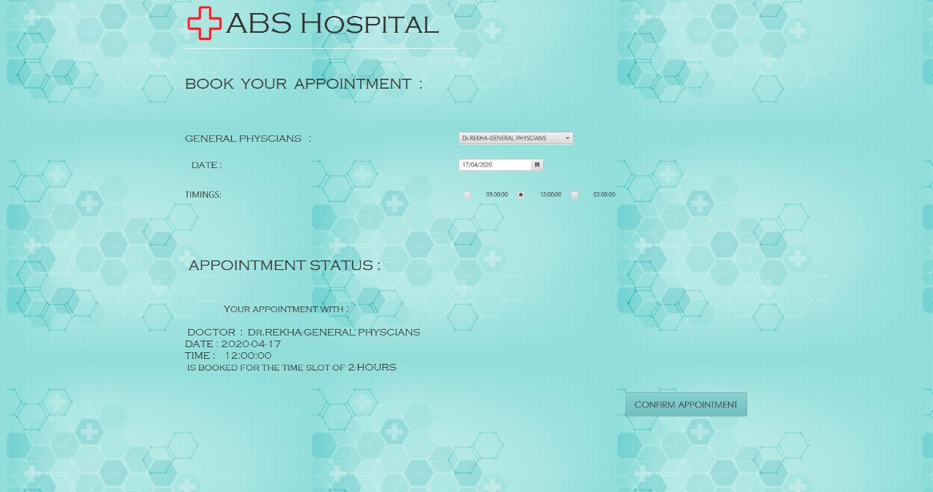

Fig: Sample of Appointment page.

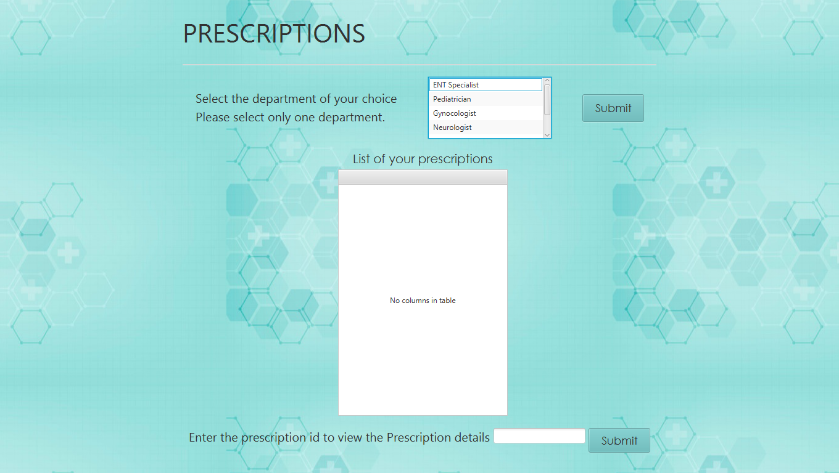

Fig: Prescriptions.

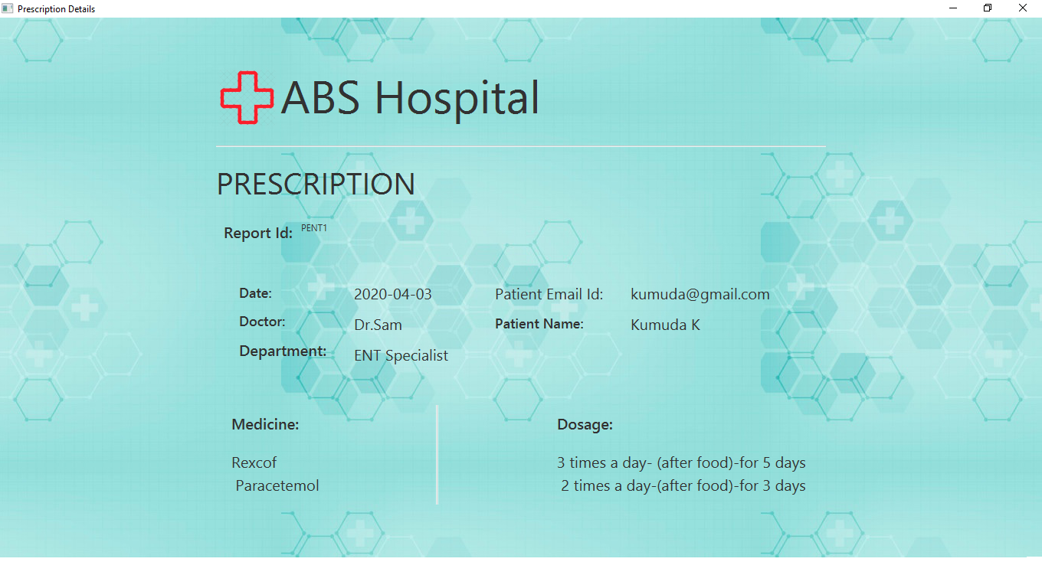Fig: Sample prescription.

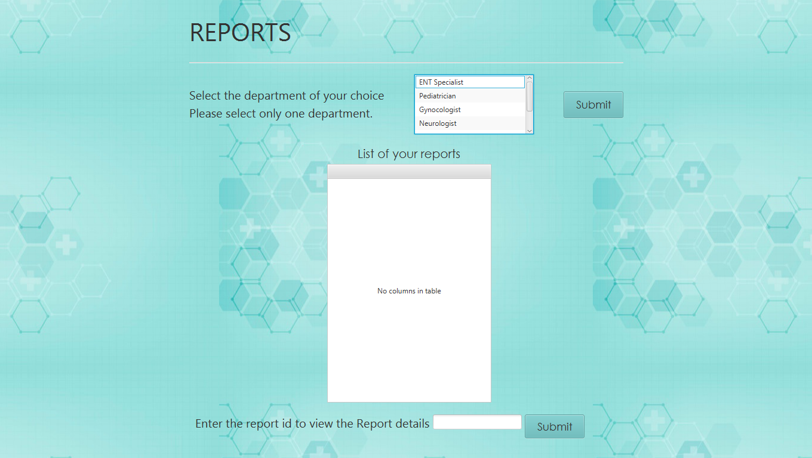

Fig: Reports.

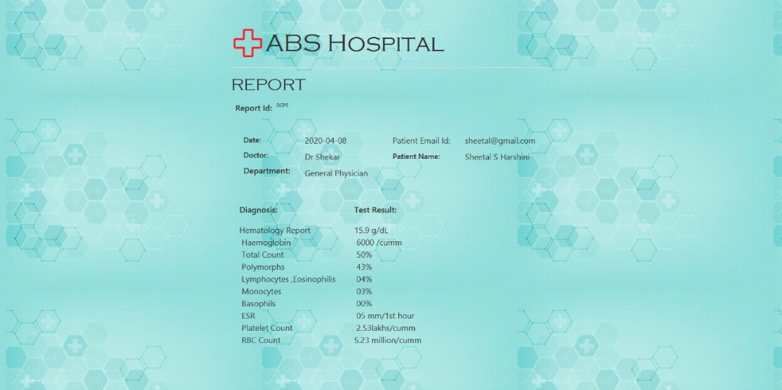

Fig: Sample Report.

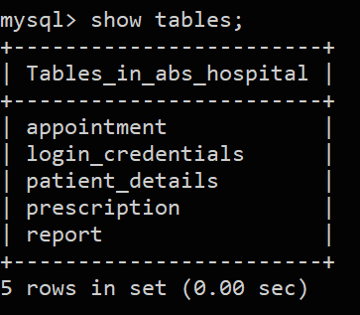

Fig: Tables of database abs_hospital.

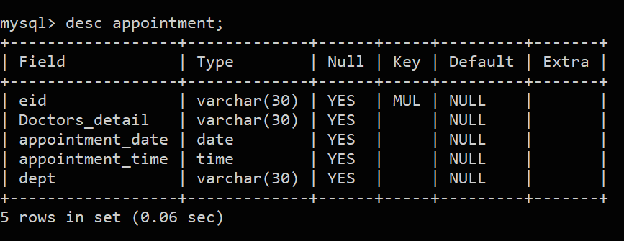

Fig: Description of appointment table.

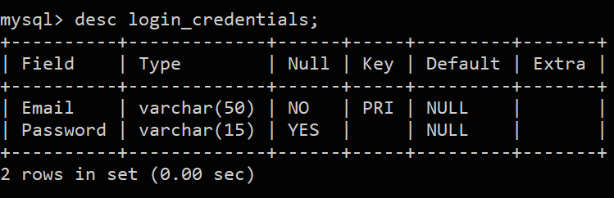

Fig: Description of login_credentials table.

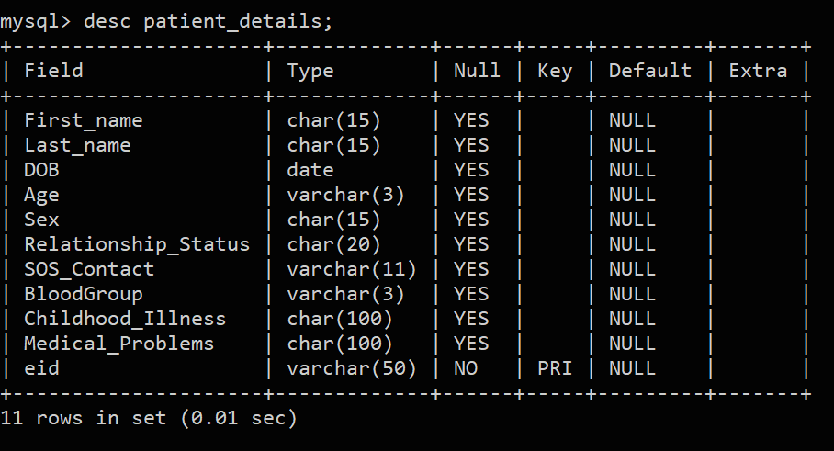

Fig: Description of pateints_details table.

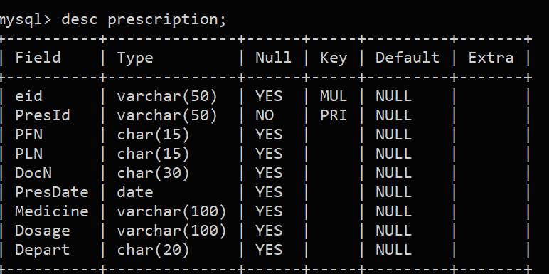

Fig: Description of prescription table.

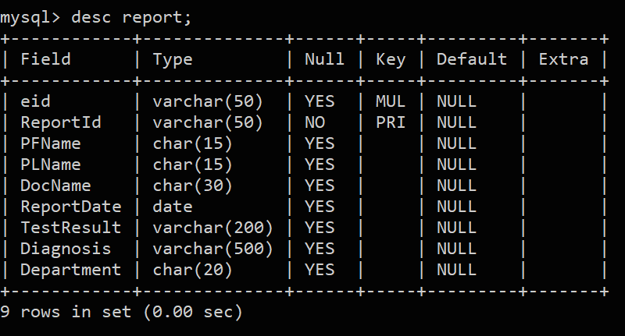

Fig: Description of report table

Chapter 6

**CONCLUSION**

ABS Hospital Appointment Booking system is all about the modernizing the chaotic process of booking appointments manually through the use of technology. Computers take over the manual system for quick, easy and hassle-free functioning. This hospital appointment booking system is quite reliable and is proven on many stages. It gives many facilities such as registering with just an email-id and a password, to enter personal details sitting at home, to obtain prescriptions prescribed by the doctors without the fear of losing the hand-written prescriptions provided by the doctors. Reports provided by the hospital is safely secured and are made easily available under the registered account. Patients in need of help can easily book an appointment beforehand by entering the date and choosing from the available time slots.

Chapter 7

**BIBLIOGRAPHY**

* **Book**

1. Schildt, Herbert. Java: The Complete Reference. 7th Edition. Tata McGraw Hill.

* **Links referred**

1. <https://docs.oracle.com/javase/8/javafx/api/javafx/scene/control/DatePicker.html>
2. <https://docs.oracle.com/javafx/2/get_started/jfxpub-get_started.htm>
3. <https://www.javatpoint.com/java-jdbc>
4. <https://dev.mysql.com/doc/refman/8.0/en/insert-on-duplicate.html>
5. <https://docs.oracle.com/javase/8/javafx/api/javafx/scene/layout/Background.html>
6. <https://stackoverflow.com/questions/49149502/button-color-change-in-javafx>
7. <https://www.javaguides.net/2019/07/login-form-using-javafx-with-mysql-database.html>
8. <https://docs.oracle.com/javase/8/javafx/api/javafx/scene/control/ComboBox.html>
9. <https://youtu.be/lNeZe-vIHwU>